Name

NSID

Quarterly Test #3: Modules 7-9 v.2
Each answer on the test is worth 1 mark, for a total of 50 marks.

- Add barlines to the following examples (15 marks).

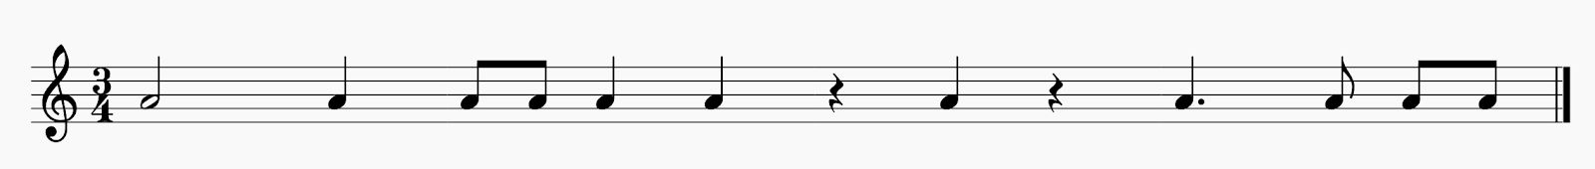
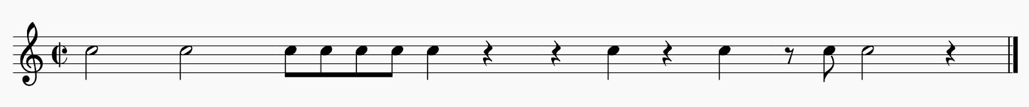

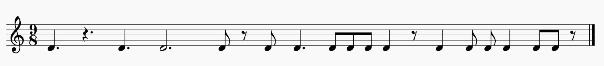

- Rewrite the notes according to the grouping and beaming rules of the given time signature below the provided examples (15 marks).

- Add rests to the examples below (10 marks).
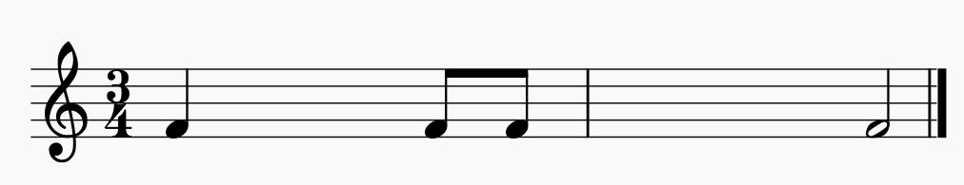

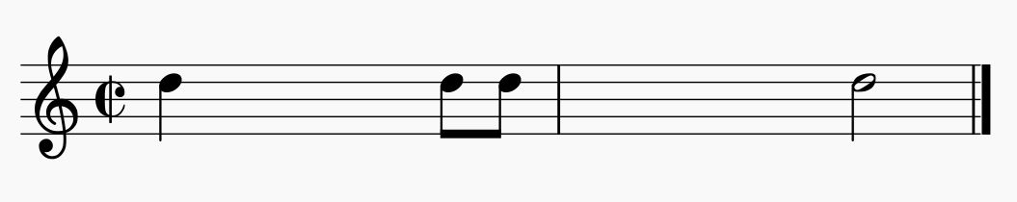

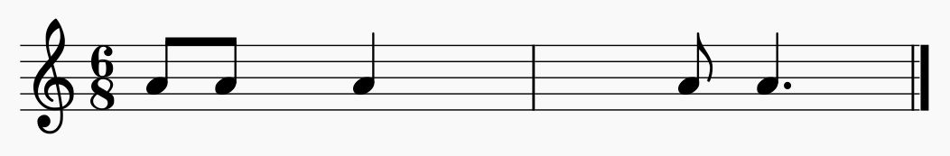

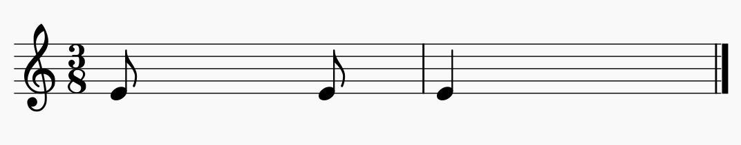
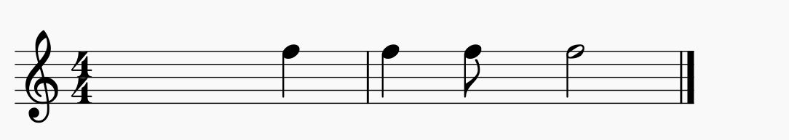

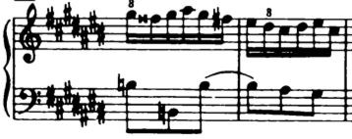
- Identify the missing time signatures for the examples below (10 marks). Example: 4

4

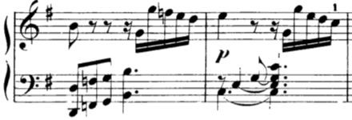
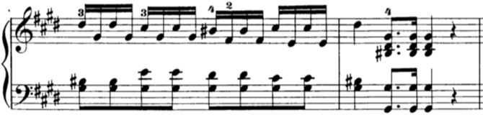

Bass Melody

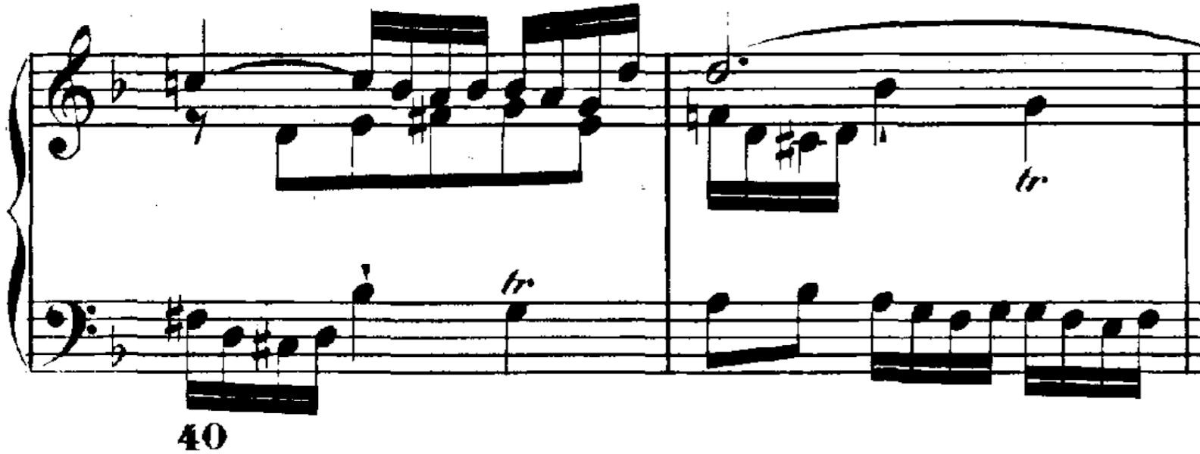

harmonic

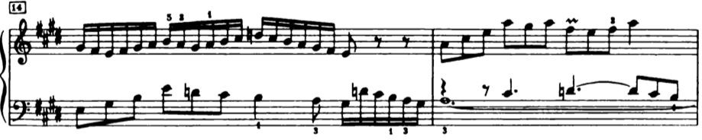
bass .

